Program - 1
Question:
Write a C program to simulate the following CPU scheduling algorithm to find turnaround time and waiting time. (Any one)
a) FCFS
b) SJF
Code:
#include <stdio.h>
#include <stdbool.h>

typedef struct process process;
struct process{
int pid;
int at;
int bt;
int ct;
int tat;
int wt;
};

void sort(process* p, int n)
{
int temp = 0;
for(int i=0;i<n;i++)
{
for(int j=i;j<n;j++)
{
if(p[j].at<p[i].at)
{
temp=p[i].pid;
p[i].pid=p[j].pid;
p[j].pid=temp;

temp=p[i].at;
p[i].at=p[j].at;
p[j].at=temp;

temp=p[i].bt;
p[i].bt=p[j].bt;
p[j].bt=temp;
}
else if(p[j].at==p[i].at)
{
if(p[j].pid<p[i].pid)
{
temp=p[i].pid;
p[i].pid=p[j].pid;
p[j].pid=temp;

temp=p[i].at;
p[i].at=p[j].at;
p[j].at=temp;

temp=p[i].bt;
p[i].bt=p[j].bt;
p[j].bt=temp;
}
}
}
}
}

void main()
{
int c=0;
int n;
printf("Enter no. of p:");
scanf("%d",&n);

process p[n];

for(int i=0;i<n;i++)
{
printf("Enter for process %d:",(i+1));
scanf("%d %d %d", &p[i].pid, &p[i].at, &p[i].bt);
}

sort(p,n);

for(int i=0;i<n;i++)
{
if(c>=p[i].at)
c+=p[i].bt;
else
c+=p[i].at+p[i].bt-p[i-1].ct;
p[i].ct = c;
}

for(int i=0;i<n;i++)
{
p[i].tat = p[i].ct - p[i].at;
p[i].wt = p[i].tat - p[i].bt;
}

double avgTAT=0, avgWT=0;
printf("pid | at | bt | ct | tat | wt\n");
for (int i = 0; i < n; i++) {
printf("%3d | %2d | %2d | %2d | %3d | %2d\n", p[i].pid, p[i].at,p[i].bt, p[i].ct, p[i].tat, p[i].wt);
avgTAT += p[i].tat;
avgWT += p[i].wt;
}
printf("ATAT:%f,AWT:%f\n",avgTAT/n,avgWT/n);
}
Result:
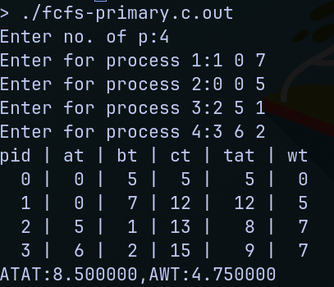
Code:
#include <stdio.h>
#include <stdlib.h>
#include <stdbool.h>

typedef struct process process;
struct process{
int pid;
int at;
int bt;
int ct;
int tat;
int wt;
};

void sjf(process* processes, int n) {
int currentTime = 0;

process temp;
for(int i=0;i<n;i++)
{
for(int j=i;j<n;j++)
{
if((processes[j].at < processes[i].at)||(processes[j].at == processes[i].at && processes[j].bt < processes[i].bt))
{
temp = processes[i];
processes[i] = processes[j];
processes[j] = temp;
}
}
}
for(int i=0;i<n;i++)
{
currentTime += processes[i].bt;
processes[i].ct = currentTime;

processes[i].tat = processes[i].ct - processes[i].at; // TAT = CT - AT
processes[i].wt = processes[i].tat - processes[i].bt; // WT = Tat - BT
}

}

void main()
{
int n;
printf("Enter n:");
scanf("%d",&n);
process* processes = (process*)malloc(n*sizeof(process));
for(int i=0;i<n;i++)
{
printf("Enter data:");
scanf("%d%d%d",&processes[i].pid,&processes[i].at,&processes[i].bt);
}

sjf(processes, n);

double avgTAT=0, avgWT=0;
printf("pid | at | bt | ct | tat | wt\n");
for (int i = 0; i < n; i++) {
printf("%3d | %2d | %2d | %2d | %3d | %2d\n", processes[i].pid, processes[i].at,processes[i].bt, processes[i].ct, processes[i].tat, processes[i].wt);
avgTAT += processes[i].tat;
avgWT += processes[i].wt;
}
printf("ATAT:%f,AWT:%f\n",avgTAT/n,avgWT/n);
}

Result:
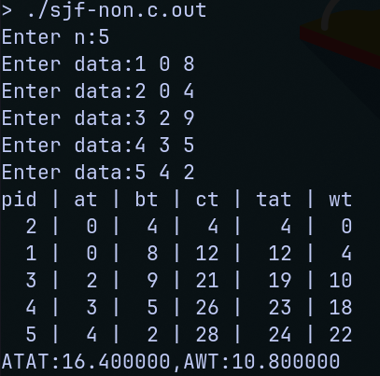
Program - 2
Question:
Write a C program to simulate multi-level queue scheduling algorithm considering the following scenario. All the processes in the system are divided into two categories – system processes and user processes. System processes are to be given higher priority than user processes. Use FCFS scheduling for the processes in each queue.
Code:
#include <stdio.h>
#include <stdlib.h>
#include <stdbool.h>

typedef struct process process;
struct process{
int pid;
int pri;
int at;
int bt;
int ct;
int tat;
int wt;
};

void sort(process* p, int n)
{
process temp;
for(int i=0;i<n;i++)
{
for(int j=i+1;j<n;j++)
{
if(p[j].at<p[i].at)
{
temp = p[j];
p[j] = p[i];
p[i] = temp;
}
}
}
}

void print(process* p, int n)
{

double avgTAT=0, avgWT=0;
printf("pid | at | bt | ct | tat | wt\n");
for (int i = 0; i < n; i++) {
p[i].tat = p[i].ct - p[i].at;
p[i].wt = p[i].tat - p[i].bt;
printf("%3d | %2d | %2d | %2d | %3d | %2d\n", p[i].pid, p[i].at,p[i].bt, p[i].ct, p[i].tat, p[i].wt);
avgTAT += p[i].tat;
avgWT += p[i].wt;
}
printf("ATAT:%f,AWT:%f\n",avgTAT/n,avgWT/n);
}

void fcfs(process* p, int n, int* ctp)
{
int c = *ctp;
for (int i = 0; i < n; i++)
{
if (c < p[i].at)
{
c = p[i].at;
}
c += p[i].bt;
p[i].ct = c;
}

*ctp = c;
}
void main()
{
int* ctp = (int*) malloc(sizeof(int));
*ctp = 0;
int n1, n2;
printf("Enter n1, n2:");
scanf("%d%d",&n1, &n2);

process sp[n1];
process up[n2];
printf("SYS\n");
for(int i=0;i<n1;i++)
{
printf("Enter the data:");
scanf("%d%d%d",&sp[i].pid, &sp[i].at, &sp[i].bt);
sp[i].pri=0;
}

printf("USR\n");
for(int i=0;i<n2;i++)
{
printf("Enter the data:");
scanf("%d%d%d",&up[i].pid, &up[i].at, &up[i].bt);
up[i].pri=1;
}
sort(sp,n1);
sort(up, n2);

fcfs(sp, n1, ctp);
fcfs(up, n2, ctp);

print(sp,n1);
print(up,n2);
}
Result:
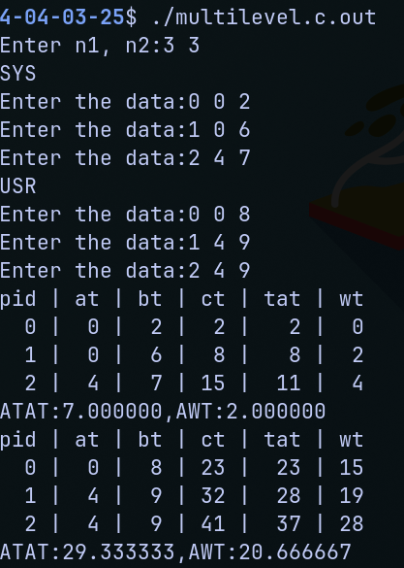

Program - 3
Question:
Write a C program to simulate Real-Time CPU Scheduling algorithms
a) Rate- Monotonic
Code:
#include <stdio.h>

#define MAX_PROCESSES 10
#define SIMULATION_TIME 30 // Total simulation time in time units

typedef struct {
int id;
int period;
int exec_time;
int next_release;
int remaining_time;
int active; // Indicates if the process is ready to run
} process;

int main() {
process processes[MAX_PROCESSES];
int n;

printf("Number of processes: ");
scanf("%d", &n);

for (int i = 0; i < n; i++) {
processes[i].id = i;
printf("Process %d period: ", i);
scanf("%d", &processes[i].period);
printf("Process %d execution time: ", i);
scanf("%d", &processes[i].exec_time);
processes[i].next_release = 0;
processes[i].remaining_time = 0;
processes[i].active = 0;
}

// Sort by period (Rate Monotonic Priority)
for (int i = 0; i < n - 1; i++) {
for (int j = i + 1; j < n; j++) {
if (processes[i].period > processes[j].period) {
process temp = processes[i];
processes[i] = processes[j];
processes[j] = temp;
}
}
}

printf("\n--- Rate Monotonic Scheduling Simulation ---\n\n");

// Simulation loop
for (int time = 0; time < SIMULATION_TIME; time++) {

// Check for new releases
for (int i = 0; i < n; i++) {
if (time == processes[i].next_release) {
if (processes[i].remaining_time > 0) {
printf("Time %d: Process %d MISSED DEADLINE\n", time, processes[i].id);
}

processes[i].next_release += processes[i].period;
processes[i].remaining_time = processes[i].exec_time;
processes[i].active = 1;
}
}

// Run highest-priority active process
int ran = 0;
for (int i = 0; i < n; i++) {
if (processes[i].active && processes[i].remaining_time > 0) {
if (processes[i].remaining_time == processes[i].exec_time)
printf("Time %d: Process %d START\n", time, processes[i].id);

processes[i].remaining_time--;

if (processes[i].remaining_time == 0) {
processes[i].active = 0;
printf("Time %d: Process %d END\n", time, processes[i].id);
}
ran = 1;
break; // Preempt lower-priority processes
}
}

if (!ran) {
printf("Time %d: IDLE\n", time);
}
}

return 0;
}

Result:
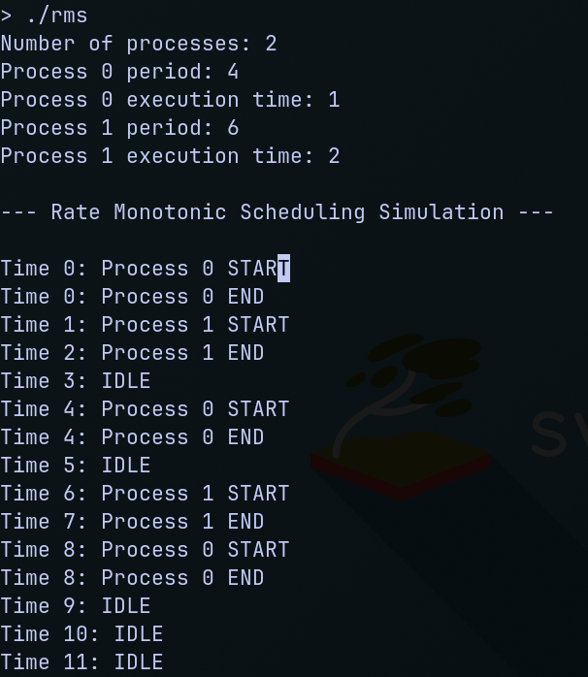
Program - 4
Question:
Write a C program to simulate:
a) Producer-Consumer problem using semaphores.
b) Dining-Philosopher’s problem
Code:
#include <stdio.h>
#include <pthread.h>
#include <unistd.h>

#define N 5
int full = 0;
int empty = N;
int mutex = 1;
int BUFFER[N];
int in = 0; // Index for producing
int out = 0; // Index for consuming

void wait(int* s) {
while (*s <= 0);
(*s)--;
}

void signal(int* s) {
(*s)++;
}

void produce(int item) {
wait(&empty);
wait(&mutex);
BUFFER[in] = item;
in = (in + 1) % N;
printf("Produced: %d\n", item);
signal(&mutex);
signal(&full);
}

void consume() {
wait(&full);
wait(&mutex);
int item = BUFFER[out];
out = (out + 1) % N;
printf("Consumed: %d\n", item);
signal(&mutex);
signal(&empty);
}

void* produce_thread(void* arg) {
int item = 1;
while (1) {
produce(item);
item++;
sleep(1);
}
return NULL;
}

void* consume_thread(void* arg) {
while (1) {
consume();
sleep(2);
}
return NULL;
}

int main() {
pthread_t producer, consumer;

pthread_create(&producer, NULL, produce_thread, NULL);
pthread_create(&consumer, NULL, consume_thread, NULL);

pthread_join(producer, NULL);
pthread_join(consumer, NULL);

return 0;
}
Result:
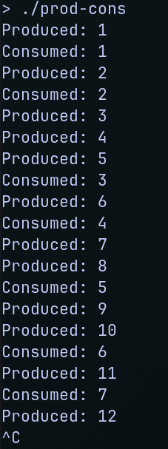
Code:
#include <stdio.h>
#include <pthread.h>
#include <unistd.h>

#define N 5 // Number of philosophers

// Define a semaphore structure to maintain each fork's state
struct semaphore {
int mutex_value; // 1 if available, 0 if not
pthread_t* waiting_list; // List of threads waiting for the fork
};

// Declare semaphores for each fork
struct semaphore forks[N];

// Declare the philosophers' threads
pthread_t philosophers[N];

// Function declarations
void* philosopher(void* arg);
void think(int id);
void eat(int id);
void take_forks(int id);
void put_forks(int id);
void wait(struct semaphore* s);
void signal(struct semaphore* s);

int main() {
// Initialize semaphores for each fork
for (int i = 0; i < N; i++) {
forks[i].mutex_value = 1; // All forks are initially available
forks[i].waiting_list = NULL; // No one is waiting initially
}

// Create philosopher threads
for (int i = 0; i < N; i++) {
pthread_create(&philosophers[i], NULL, philosopher, (void*)(long)i);
}

// Join philosopher threads (they run forever in this case)
for (int i = 0; i < N; i++) {
pthread_join(philosophers[i], NULL);
}

return 0;
}

void* philosopher(void* arg) {
int id = (int)(long)arg;
while (1) {
think(id);
take_forks(id);
eat(id);
put_forks(id);
}
}

void think(int id) {
printf("Philosopher %d is thinking.\n", id);
sleep(1); // Thinking for some time
}

void eat(int id) {
printf("Philosopher %d is eating.\n", id);
sleep(2); // Eating for some time
}

void take_forks(int id) {
// Wait for the left fork
wait(&forks[id]);

// Wait for the right fork (next fork in circular manner)
wait(&forks[(id + 1) % N]);

printf("Philosopher %d took both forks.\n", id);
}

void put_forks(int id) {
// Release the left fork
signal(&forks[id]);

// Release the right fork (next fork in circular manner)
signal(&forks[(id + 1) % N]);

printf("Philosopher %d put down both forks.\n", id);
}

void wait(struct semaphore* s) {
// If the semaphore is not available, block the philosopher and wait
while (s->mutex_value <= 0) ;
s->mutex_value = 0; // Fork is now taken by the philosopher
}

void signal(struct semaphore* s) {
s->mutex_value = 1; // Fork is now available
}
Result:
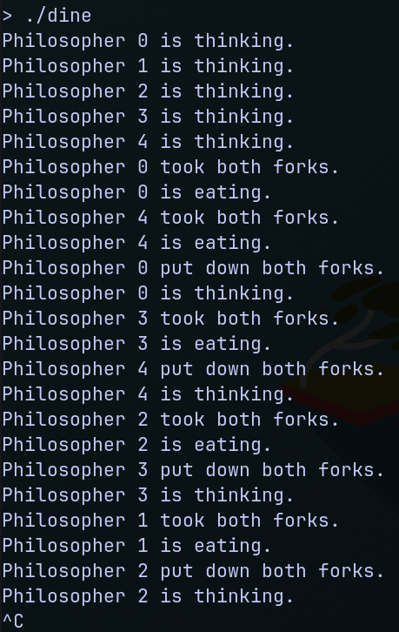
Program - 5
Question:
Write a C program to simulate:
a) Bankers’ algorithm for the purpose of deadlock avoidance.
Code:
#include <stdio.h>
#include <stdbool.h>

int main() {
int P, R;

printf("Enter number of processes: ");
scanf("%d", &P);
printf("Enter number of resource types: ");
scanf("%d", &R);

int Allocation[P][R], Max[P][R], Need[P][R], Available[R];
bool Finish[P];
int Work[R], SafeSequence[P];

// Input Allocation matrix
printf("Enter Allocation matrix (%d x %d):\n", P, R);
for (int i = 0; i < P; i++)
for (int j = 0; j < R; j++)
scanf("%d", &Allocation[i][j]);

// Input Max matrix
printf("Enter Max matrix (%d x %d):\n", P, R);
for (int i = 0; i < P; i++)
for (int j = 0; j < R; j++)
scanf("%d", &Max[i][j]);

// Input Available vector
printf("Enter Available resources (%d):\n", R);
for (int i = 0; i < R; i++)
scanf("%d", &Available[i]);

// Calculate Need matrix = Max - Allocation
for (int i = 0; i < P; i++)
for (int j = 0; j < R; j++)
Need[i][j] = Max[i][j] - Allocation[i][j];

// Initialize
for (int i = 0; i < R; i++)
Work[i] = Available[i];
for (int i = 0; i < P; i++)
Finish[i] = false;

int count = 0;

while (count < P) {
bool found = false;
for (int i = 0; i < P; i++) {
if (!Finish[i]) {
bool canRun = true;
for (int j = 0; j < R; j++) {
if (Need[i][j] > Work[j]) {
canRun = false;
break;
}
}

if (canRun) {
for (int j = 0; j < R; j++)
Work[j] += Allocation[i][j];
SafeSequence[count++] = i;
Finish[i] = true;
found = true;
}
}
}

if (!found) {
printf("System is NOT in a safe state.\n");
return 1;
}
}

printf("System is in a safe state.\nSafe sequence: ");
for (int i = 0; i < P; i++)
printf("P%d ", SafeSequence[i]);
printf("\n");

return 0;
}
Result:
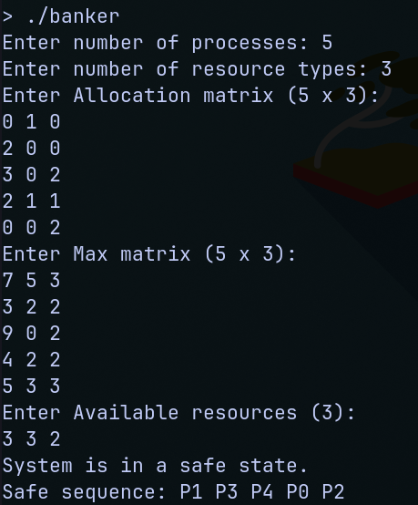
Program - 6
Question:
Write a C program to simulate the following contiguous memory allocation techniques.
a) Worst-fit
b) Best-fit
c) First-fit
Code:
#include <stdio.h>
#include <stdlib.h>
#include <stdbool.h>
#include <time.h>

typedef struct part part;
struct part {
int size;
int pro;
part* next;
};

part* create() {
part* node = (part*)malloc(sizeof(part));
node->size = 0;
node->next = NULL;
node->pro = -1; // -1 means the partition is free
return node;
}

void mempart(part* ptr, int pro, int size) {
part* npart = create();
npart->size = ptr->size - size;
npart->next = ptr->next;
ptr->pro = pro;
ptr->size = size;
ptr->next = npart;
}

void worst_fit(part* head, int pro, int size) {
part* temp = head;
part* largest = NULL;
while (temp != NULL) {
if (temp->pro == -1 && temp->size >= size) {
if (largest == NULL || temp->size > largest->size)
largest = temp;
}
temp = temp->next;
}
if (largest != NULL) {
mempart(largest, pro, size);
}
}

void first_fit(part* head, int pro, int size) {
part* temp = head;
while (temp != NULL) {
if (temp->pro == -1 && temp->size >= size) {
mempart(temp, pro, size);
break;
}
temp = temp->next;
}
}

void best_fit(part* head, int pro, int size) {
part* temp = head;
part* best = NULL;
while (temp != NULL) {
if (temp->pro == -1 && temp->size >= size) {
if (best == NULL || temp->size < best->size)
best = temp;
}
temp = temp->next;
}
if (best != NULL) {
mempart(best, pro, size);
}
}

void printPart(part* head) {
part* temp = head;
while (temp != NULL) {
if (temp->pro == -1) {
printf("Empty:%d ", temp->size);
} else {
printf("P%d:%d ", temp->pro, temp->size);
}
temp = temp->next;
}
printf("\n");
}

part* clone(part* head) {
if (head == NULL) {
return NULL;
}

part* newHead = create();
newHead->size = head->size;
newHead->pro = head->pro;
part* temp = head->next;
part* newTemp = newHead;

while (temp != NULL) {
part* newNode = create();
newNode->size = temp->size;
newNode->pro = temp->pro;
newTemp->next = newNode;
newTemp = newNode;
temp = temp->next;
}

return newHead;
}

// Random initial memory fragmentation and allocation
void random_allocate(part* head, int n, int p[]) {
int total_size;
printf("Enter total memory size: ");
scanf("%d", &total_size);

int remaining = total_size;
head->size = 0; // Dummy head; will replace later
part* current = head;

printf("Randomly allocating initial memory...\n");

while (remaining > 0) {
int split_size = (rand() % (remaining / 2 + 1)) + 1;
if (split_size > remaining) split_size = remaining;

bool assign_process = rand() % 2 == 0;

part* node = create();
node->size = split_size;

if (assign_process && n > 0) {
int idx = rand() % n;
if (p[idx] <= split_size) {
node->pro = idx;
printf("Allocated P%d of size %d\n", idx, split_size);
} else {
node->pro = -1;
printf("Empty:%d\n", split_size);
}
} else {
node->pro = -1;
printf("Empty:%d\n", split_size);
}

current->next = node;
current = node;
remaining -= split_size;
}

// Remove dummy head and promote first real partition
part* realHead = head->next;
free(head);
*head = *realHead;
free(realHead);
}

int main() {
srand(time(0)); // Seed for random number generation

part* head = create();

int n;
printf("Enter number of processes: ");
scanf("%d", &n);
int p[n];
printf("Enter process sizes:\n");
for (int i = 0; i < n; i++) {
scanf("%d", &p[i]);
}

// Generate random memory with some pre-allocated processes
random_allocate(head, n, p);

while (true) {
part* clonedHead = clone(head);

int choice;
printf("\n1.First Fit 2.Best Fit 3.Worst Fit 4.Exit: ");
scanf("%d", &choice);

if (choice == 4) {
break;
}

switch (choice) {
case 1:
for (int i = 0; i < n; i++) {
first_fit(clonedHead, i, p[i]);
}
break;
case 2:
for (int i = 0; i < n; i++) {
best_fit(clonedHead, i, p[i]);
}
break;
case 3:
for (int i = 0; i < n; i++) {
worst_fit(clonedHead, i, p[i]);
}
break;
default:
printf("Invalid choice!\n");
continue;
}

printPart(clonedHead);
}

return 0;
}

Result:
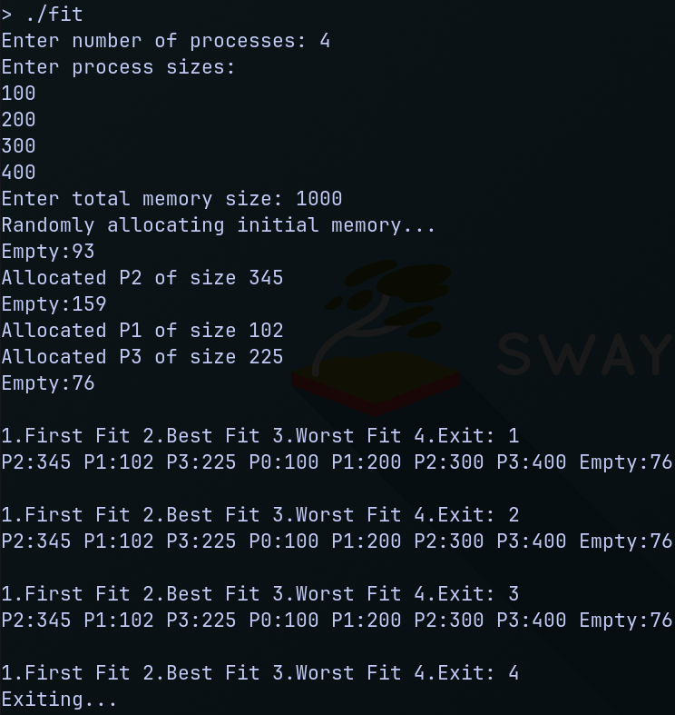
Program - 7
Question:
Write a C program to simulate page replacement algorithms.
a) FIFO
b) LRU
c) Optimal
Code:
#ifndef PAGE_REPLACEMENT_H
#define PAGE_REPLACEMENT_H

#include <stdio.h>

// Macro for taking user input
#define GET_INPUT(frames, pages, refString) \
printf("Enter number of frames: "); \
scanf("%d", &frames); \
printf("Enter number of pages: "); \
scanf("%d", &pages); \
printf("Enter reference string: "); \
for (int i = 0; i < pages; i++) { \
scanf("%d", &refString[i]); \
}

// Macro for initializing frames
#define INIT_FRAMES(frames, frame, counter) \
for (int i = 0; i < frames; i++) { \
frame[i] = -1; \
if (counter != NULL) counter[i] = 0; \
}

// Macro for displaying frame contents
#define DISPLAY_FRAMES(page, frames, frame) \
printf("%d: ", page); \
for (int i = 0; i < frames; i++) { \
printf("%d ", frame[i]); \
} \
printf("\n");

// Macro for printing total page faults
#define PRINT_PAGE_FAULTS(pageFaults) \
printf("Total Page Faults: %d\n", pageFaults);

#endif
Code:
#include "page_replacement.h"

int main() {
int frames, pages, pageFaults = 0, current = 0;
int referenceString[100], frame[100]; // Max size to prevent runtime issues

GET_INPUT(frames, pages, referenceString);

// Initialize frames
for (int i = 0; i < frames; i++) {
frame[i] = -1;
}

for (int i = 0; i < pages; i++) {
int found = 0;
for (int j = 0; j < frames; j++) {
if (frame[j] == referenceString[i]) {
found = 1;
break;
}
}
if (!found) {
frame[current] = referenceString[i];
current = (current + 1) % frames;
pageFaults++;
}
DISPLAY_FRAMES(referenceString[i], frames, frame);
}

PRINT_PAGE_FAULTS(pageFaults);
return 0;
}
Code:
#include "page_replacement.h"

int main() {
int frames, pages, pageFaults = 0;
int referenceString[100], frame[100]; // Frame contents
int lastUsed[100]; // Tracks last used time of each frame slot

GET_INPUT(frames, pages, referenceString);

// Initialize frames and usage history
for (int i = 0; i < frames; i++) {
frame[i] = -1;
lastUsed[i] = -1;
}

for (int time = 0; time < pages; time++) {
int currentPage = referenceString[time];
int found = 0;

// Check if current page is already in frame
for (int j = 0; j < frames; j++) {
if (frame[j] == currentPage) {
found = 1;
lastUsed[j] = time; // Update usage time
break;
}
}

// Page fault
if (!found) {
int index = -1;

// Find an empty frame
for (int j = 0; j < frames; j++) {
if (frame[j] == -1) {
index = j;
break;
}
}

// No empty frame; replace LRU
if (index == -1) {
int minTime = time;
for (int j = 0; j < frames; j++) {
if (lastUsed[j] < minTime) {
minTime = lastUsed[j];
index = j;
}
}
}

frame[index] = currentPage;
lastUsed[index] = time;
pageFaults++;
}

DISPLAY_FRAMES(currentPage, frames, frame);
}

PRINT_PAGE_FAULTS(pageFaults);
return 0;
}
Code:
#include "page_replacement.h" // Ensure this header provides: GET_INPUT, DISPLAY_FRAMES, PRINT_PAGE_FAULTS

int main() {
int frames, pages, pageFaults = 0;
int referenceString[100], frame[100];

GET_INPUT(frames, pages, referenceString);

// Initialize all frames to -1 (indicating empty)
for (int i = 0; i < frames; i++) {
frame[i] = -1;
}

// Traverse through each page in the reference string
for (int i = 0; i < pages; i++) {
int currentPage = referenceString[i];
int found = 0;

// Check if the page is already in one of the frames (page hit)
for (int j = 0; j < frames; j++) {
if (frame[j] == currentPage) {
found = 1;
break;
}
}

// If not found (page fault)
if (!found) {
int replaceIndex = -1;

// First, check for any empty frame
for (int j = 0; j < frames; j++) {
if (frame[j] == -1) {
replaceIndex = j;
break;
}
}

// If no empty frame, find the page used farthest in future
if (replaceIndex == -1) {
int farthest = -1;

for (int j = 0; j < frames; j++) {
int nextUse = pages; // Default: not used again

// Look ahead in the reference string
for (int k = i + 1; k < pages; k++) {
if (frame[j] == referenceString[k]) {
nextUse = k;
break;
}
}

// Select the frame with the farthest use
if (nextUse > farthest) {
farthest = nextUse;
replaceIndex = j;
}
}
}

// Replace the selected frame with the current page
frame[replaceIndex] = currentPage;
pageFaults++;
}

// Display current frame contents after this page reference
DISPLAY_FRAMES(currentPage, frames, frame);
}

// Output total page faults
PRINT_PAGE_FAULTS(pageFaults);
return 0;
}
Result:
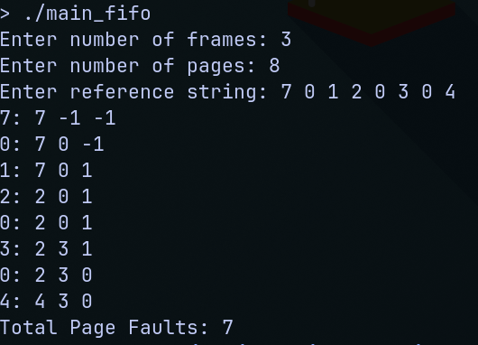
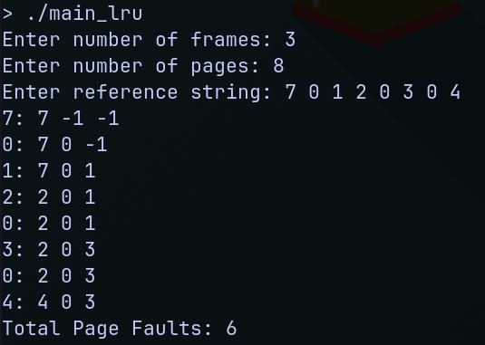
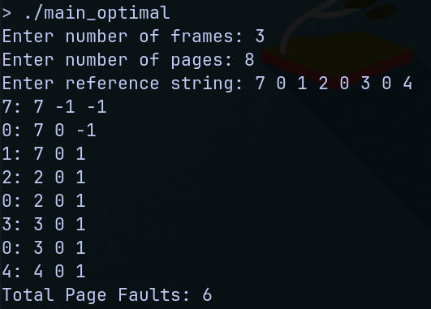
Program - 8
Question:
Write a C program to simulate the following file allocation strategies.
a) Sequential
b) Indexed
c) Linked
Code:
#include <stdio.h>
#include <stdlib.h>
#include <string.h>

#define DISK_SIZE 100

int disk[DISK_SIZE]; // 0 = free, 1 = allocated

// For indexed allocation
typedef struct {
char name[20];
int indexBlock;
int blocks[10];
int size;
} IndexedFile;

// For linked allocation
typedef struct Node {
int block;
struct Node* next;
} Node;

typedef struct {
char name[20];
Node* start;
int size;
} LinkedFile;

void resetDisk() {
for (int i = 0; i < DISK_SIZE; i++)
disk[i] = 0;
}

void sequentialAllocation() {
char name[20];
int start, length;

printf("\n--- Sequential Allocation ---\n");
printf("Enter file name: ");
scanf("%s", name);
printf("Enter starting block: ");
scanf("%d", &start);
printf("Enter length (number of blocks): ");
scanf("%d", &length);

if (start + length > DISK_SIZE) {
printf("Error: File exceeds disk size.\n");
return;
}

for (int i = start; i < start + length; i++) {
if (disk[i] == 1) {
printf("Error: Block %d already allocated.\n", i);
return;
}
}

for (int i = start; i < start + length; i++) {
disk[i] = 1;
}

printf("File '%s' allocated from block %d to %d.\n", name, start, start + length - 1);
}

void indexedAllocation() {
IndexedFile file;
printf("\n--- Indexed Allocation ---\n");
printf("Enter file name: ");
scanf("%s", file.name);
printf("Enter number of blocks needed: ");
scanf("%d", &file.size);

printf("Enter index block: ");
scanf("%d", &file.indexBlock);

if (disk[file.indexBlock] == 1) {
printf("Error: Index block already in use.\n");
return;
}

int count = 0;
for (int i = 0; i < DISK_SIZE && count < file.size; i++) {
if (disk[i] == 0 && i != file.indexBlock) {
file.blocks[count++] = i;
}
}

if (count < file.size) {
printf("Error: Not enough free blocks.\n");
return;
}

disk[file.indexBlock] = 1;
for (int i = 0; i < file.size; i++) {
disk[file.blocks[i]] = 1;
}

printf("File '%s' allocated with index block %d and data blocks: ", file.name, file.indexBlock);
for (int i = 0; i < file.size; i++) {
printf("%d ", file.blocks[i]);
}
printf("\n");
}

void linkedAllocation() {
LinkedFile file;
printf("\n--- Linked Allocation ---\n");
printf("Enter file name: ");
scanf("%s", file.name);
printf("Enter number of blocks needed: ");
scanf("%d", &file.size);

Node* head = NULL;
Node* current = NULL;
int count = 0;

for (int i = 0; i < DISK_SIZE && count < file.size; i++) {
if (disk[i] == 0) {
disk[i] = 1;
Node* newNode = (Node*)malloc(sizeof(Node));
newNode->block = i;
newNode->next = NULL;

if (head == NULL) {
head = newNode;
current = newNode;
} else {
current->next = newNode;
current = newNode;
}
count++;
}
}

if (count < file.size) {
printf("Error: Not enough free blocks.\n");
return;
}

file.start = head;

printf("File '%s' allocated at blocks: ", file.name);
Node* temp = head;
while (temp) {
printf("%d -> ", temp->block);
temp = temp->next;
}
printf("NULL\n");
}

int main() {
int choice;
while (1) {
printf("\nFile Allocation Strategies:\n");
printf("1. Sequential Allocation\n");
printf("2. Indexed Allocation\n");
printf("3. Linked Allocation\n");
printf("4. Reset Disk\n");
printf("5. Exit\n");
printf("Enter your choice: ");
scanf("%d", &choice);

switch (choice) {
case 1:
sequentialAllocation();
break;
case 2:
indexedAllocation();
break;
case 3:
linkedAllocation();
break;
case 4:
resetDisk();
printf("Disk reset.\n");
break;
case 5:
printf("Exiting.\n");
return 0;
default:
printf("Invalid choice.\n");
}
}

return 0;
}
Result:
